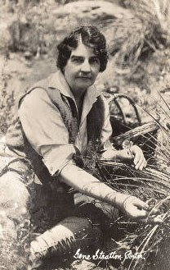

The Gene Stratton-Porter Environmental Science Award

Nomination Packet must include:

Candidate Information

Name:
Title/Affiliation:
Complete Work Address:
Telephone (inc. area code):
Email address:

Complete Home Address:
Telephone (inc. area code):

Nominator Information (if applicable)

Name:
Complete Address:
Telephone (inc. area code):
Email address:

- Vita of Nominee (Include a work history, honors or recognition received, and examples of leadership within their profession.)

- Candidates must submit an innovative, replicable project, lesson plan, and/or curriculum scope and sequence that brings attention to Indiana’s natural ecosystems and the importance of those ecosystems to local environments. The entry should have been either developed or implemented in the prior year. The winning entry will be published in the Hoosier Science Teacher and made available on the HASTI.org website as a pdf for teacher access and dissemination.

- Two letters of support from supervisors, or colleagues describing how the candidate exemplifies the qualities in the description of the award.

Applications will not be returned. Late applications will not be accepted. All material must be in one email, a single pdf file is preferred. Completed applications must be received by November 10, 2017.

Send your original application, supporting materials to AwardsManager@hasti.org

Questions? Please visit our website at www.hasti.org or email AwardsManager@hasti.org

