**HASTI Strategic Plan**

**2020- 2025**



**Approved by the HASTI Board of Directors on**

**August 3, 2019**

**HASTI Strategic Planning session approved and authorized by** **HASTI Board Members August 14, 2003.**

**HASTI Strategic Planning sessions held:**

* **November 1, 2003 at Sunnyside Elementary, Indianapolis, Indiana**
* **November 14-16, 2003 at Spring Mill State Park, Mitchell, Indiana Authors of HASTI Strategic Plan:**
* **Ed Frazier, Executive Director**
* **Sharon McElroy, President**
* **Carol Chen, Past President**
* **Stan Shimer, Past President**
* **Monica Ellis, President Elect**
* **Christina Hilton, Board Member**

**HASTI Strategic Plan facilitated by Ken Rosenbaum, NSTA Field Coordinator, Chapter Relations**.

**HASTI Strategic Plan 2010-2015**

**Approval by the HASTI Board of Directors on August 20, 2011**

**HASTI Strategic Plan 2015-2020**

**Approved by the HASTI Board of Directors on August, 2015**

**HASTI Strategic Planning sessions held:**

* **June 24, 2014 a IUPUC, Columbus, Indiana**
* **September 27, 2014 at Indiana State Museum, Indianapolis, Indiana**
* **November 22, 2014 at IUPUC, Columbus, Indiana**
* **February 11, 2015 at HASTI conference Board meeting, Indianapolis, Indiana**
* **May 2, 2015 at Vino Villa, Greenwood, Indiana**

**Authors of HASTI Strategic Plan:**

* **Kate Baird, President**
* **John Moore, Past President**
* **Tom McConnell, Vice Past President**
* **John Brady, PD committee chair**
* **HASTI Board members**
* **HASTI Affiliated group representatives**

**HASTI Strategic Plan 2020- 2025**

**Approved by the HASTI Board of Directors on August 3, 2015**

**HASTI Strategic Planning sessions held:**

* **June 24, 2019 via Zoom**
* **July 15, 2019 at NCSE Congress**

**Authors of HASTI Strategic Plan:**

* **Carolyn Hayes, Executive Director**
* **Shannon Hudson , President**
* **Kristen Poindexter, Vice President**
* **Katherine Lane, Conference Exhibits Chairperson**
* **HASTI Board members**
* **HASTI Affiliated group representatives**

**HASTI Strategic Plan 2020- 2025**

**Introduction**

The Hoosier Association of Science Teachers, Inc., is a community of professional educators, scientists, students, and businesses most of which reside in the State of Indiana. The HASTI has grown substantially since it was founded in 1969 with the help of NSTA, the DOE and several key state teachers. Membership now includes elementary, middle school, high school, community college, and college/ university levels as well as informal science organizations and companies. The Board of Directors in conjunction with the executive director have developed a strategic plan that reflects the changing landscape of what it means to educate a science literate and global citizen in the 21st century. The context on which this plan was developed reflects the recent urgency in reforming science education at all levels. It takes into consideration the difficulty in teaching today and creates a common vision around collaboration and partnerships with professional science societies and other science education organizations. The goals and objectives that follow will guide the capacity building necessary to maximize HASTI’s impact while achieving financial stability and organizational growth over the next five years.

**Planning Issues:**

1. Recent reauthorization of ESSA (every Student Succeeds Act) and new State Science Standards will necessitate changes in Indiana science instructional policies.
2. The nature of HASTI’s internal structure and processes determines the levels of organizational effectiveness and efficiency achieved by the association.
3. The roles and responsibilities of HASTI’s Executive Director and the volunteer leadership will need to be evaluated for the association to be effective.
4. Indiana has adopted new science standards and the STEM Strategic Plan. This will increase the need for effective science professional development.
5. HASTI represents the science educators of Indiana as their state’s professional development association.
6. There continues to be legislative intrusion into education at the local, state and national level. Testing and accountability drive funding and therefore curricular choices.
7. HASTI will advocate for science education in Indiana.

**Mission Statement**: The purpose of HASTI is the advancement and stimulation, extension, improvement, and coordination of science education in for all students in all fields of science at all educational levels. HASTI founders, 1969.

**Vision Statement:** HASTI recognizes that science education actively engages students at all levels in science as a way of knowing. We envision HASTI as the respected State organization that will provide opportunities for professional development, networking of educators, and information sharing and the proactive voice for all Indiana science educators.

**Goals:**

**Goal 1.** Provide ongoing professional development for the improvement of science education **Goal 2.** Improve sharing of information and networking opportunities for teachers of science.

**Goal 3.** Increase HASTI membership.

**Goal 4.** Become the proactive voice for teachers of science.

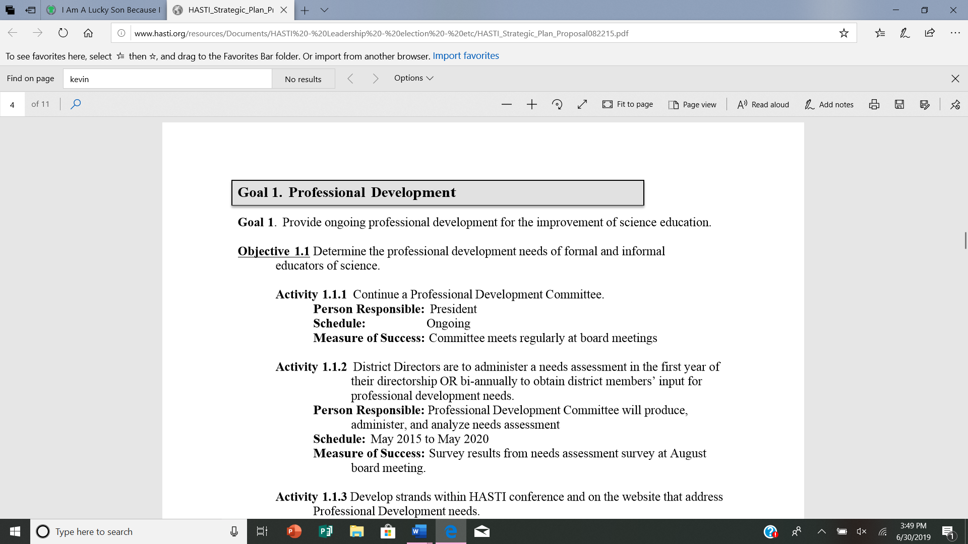

**Goal 1**. Provide ongoing professional development for the improvement of science education.

**Objective 1.1** Determine the professional development needs of formal and informal educators of science.

**Activity 1.1.1** Continue a Professional Development Committee.

**Person Responsible:** President

**Schedule:**  Ongoing

**Measure of Success:** Committee reports regularly at board meetings

**Activity 1.1.2** District Directors are to administer a needs assessment in the first year of their directorship OR bi-annually to obtain district members’ input for professional development needs.

**Person Responsible:** Professional Development Committee will produce, administer, and analyze needs assessment

**Schedule:** May 2020 to May 2025

**Measure of Success:** Survey results from needs assessment survey at August board meeting.

**Activity 1.1.3** Develop strands within HASTI conference and on the website that address Professional Development needs.

**Person Responsible:** Conference Committee in conjunction with Professional Development Committee

**Schedule:** May 2020 to May 2025

**Measure of Success:** Strands evaluated, and website populated.

**Objective 1.2** Provide Professional Development opportunities directly or through strategic partnerships to all science educators.

**Activity 1.2.1** Identify professional development opportunities statewide and serve as a clearinghouse to communicate them with membership through our website. **Person Responsible:** Professional Development Committee with Department of Education (DOE) consultation

**Schedule:** May 2020 to May 2025

**Measure of Success:** Professional development page on HASTI website populated with professional development opportunities in the Members Only section

**Activity 1.2.2** Provide presenter contact information and presentation material hosted on the HASTI website Members Only Section to all members.

**Person Responsible:** Conference Chair, District Director

**Schedule:** May 2020 to May 2025

**Measure of Success:** New webpage in conference tab with presentation material and presenter contact information

**Activity 1.2.3** Develop and offer a Nature of Science, Science and Engineering Process Skills, STEM webinars for viewing behind the Members Only section: and a What is HASTI? webinar to be left for public view

**Person Responsible:** HASTI professional development committee

**Schedule:** May 2020 to May 2025

**Measure of Success:** The posting of said webinars and solicit input from educators as to their perceived needs for professional development in science education.

**Activity 1.2.4** Work to make professional development offerings available via HASTI web page.

**Person Responsible:** HASTI PD committee and Webmaster

**Schedule:** May 2020 to May 2025

**Measure of Success:** Increased web page traffic and populated webpage for teacher resources.

**Activity 1.2.5** Continually work to support standards implementation.

**Person Responsible:** HASTI PD committee with Department of Education Consultation

**Schedule:** May 2020 to May 2025

**Measure of Success:** Creation of standards implementation guide. 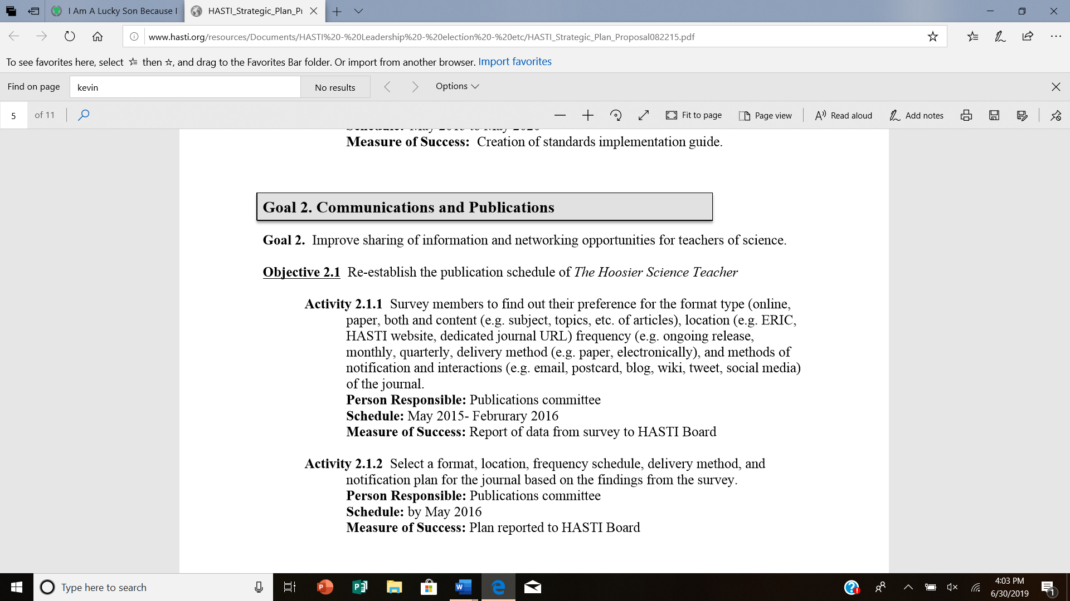

**Goal 2.** Improve sharing of information and networking opportunities for teachers of science

**Objective 2.1** Continue publication of *The Hoosier Science Teacher*

**Activity 2.1.1** Continue to publish *The Hoosier Science Teacher* electronically.

**Person Responsible:** Publications committee

**Schedule:**  May 2020 to May 2025

**Measure of Success:** Articles uploaded to the website on a consistent basis

**Activity 2.1.2** Publish completed and vetted articles when theyare approved on a rolling basis.

**Person Responsible:** Publications committee

**Schedule:** May 2020 to May 2025

**Measure of Success:** Plan reported to HASTI Board

**Activity 2.1.3 Each** board member will shepherd one submission for review by the editorial board each calendar year.

**Person Responsible:** HASTI Board Members & Publication Committee

**Schedule:** Ongoing

**Measure of Success:** May 2020 – May 2025

**Activity 2.1.4** Approve a policy that governs access and use rights to the journal’s past and future publications for members and non-members of HASTI.

**Person Responsible:** Developed by Editorial Board, approved by the Board of Directors

**Schedule:** May 2020 – May 2025

**Measure of Success:** Approval of policy by HASTI Board.

**Activity 2.1.5** Provide resources to convert selected articles and issues of *THST* to electronic format that can be stored in digital format and made available consistent with the above policy.

**Person Responsible:** HASTI Board of Directors,

Publications Committee

**Schedule:** ongoing

**Measure of Success:** Publication of archived *THST* on HASTI website.

**Objective 2.2** Deliver information to members through the HASTI website

**Activity 2.2.1** Establish a Communication Liaison position to serve on the Board without voting rights.

**Person Responsible:** Board vote; to be determined by the Board

**Schedule:** August 2019

**Measure of Success:** Creation of the position

**Activity 2.2.2** The Communication Liaison will create an advisory committee to monitor and update the website

**Person Responsible:** Communication Liaison and committee

**Schedule:** ongoing

**Measure of Success:** continual update of website

**Activity 2.2.3** Develop strategies and activities to produce the content to be shared via the website

**Person Responsible:** Communication Liaison and committee

**Schedule:** ongoing

**Measure of Success:** Publication of updated information on website

**Activity 2.2.4** Establish a procedure for evaluating HASTI’s website that include member feedback.

**Person Responsible:** Communication Liaison and committee

**Schedule:** ongoing

**Measure of Success:** Approved policy in Board minutes.

**Objective 2.3** Maintain an active social media presence for the HASTI organization

**Activity 2.3.1** Identify a social media manager and an advisory committee to manage content for HASTI’s use of social media.

**Person Responsible:** Communication Liaison and committee

**Schedule:** September 2019

**Measure of Success:** establishment of advisory committee

**Activity 2.3.2** Update and maintain links to HASTI’s social media presence.

**Person Responsible:** Communication Liaison and committee

**Schedule:** ongoing

**Measure of Success:** Current information published in social media

**Activity 2.3.3** Allocate $1000 a year to hire a work-study student to assist the social media manager.

**Person Responsible:** Communication Liaison and committee

**Schedule:** ongoing

**Measure of Success:** Budget allocation and hiring of student assistant

**Activity 2.3.4** Develop an approved policy for types of content to be included in HASTI’s social media posts.

**Person Responsible:** Communication Liaison and committee

**Schedule:** by February 2020

**Measure of Success:** approved policy in Board minutes

**Activity 2.3.5** Establish a procedure for evaluating HASTI’s use of social media that includes member feedback.

**Person Responsible:** Communication Liaison and committee

**Schedule:** ongoing

**Measure of Success:** annual report of user feedback to HASTI board

**Activity 2.3.6** Identify emerging technologies that may be used to communicate with

members

**Person Responsible:** Communication Liaison and committee

**Schedule:** ongoing

**Measure of Success:**  Annual review of alternative media options

**Objective 2.4** Network with associated groups and other stakeholders in science education

**Activity 2.4.1** Investigate opportunities for shared conferences.

**Person Responsible:** HASTI Executive Committee, NSTA District representative

**Schedule:** ongoing

**Measure of Success:** Shared conferences

**Activity 2.4.2** Continue to include representative of other content-specific associations in Indiana on the HASTI board of directors

**Person Responsible:** HASTI President and Board of Directors

**Schedule:** ongoing

**Measure of Success:** Continuing representation by affiliated organizations

**Activity 2.4.3** Encourage participation in neighboring states’ science teaching conferences by HASTI leaders

**Person Responsible:** HASTI Executive Board

**Schedule:** ongoing

**Measure of Success:** Attendance by Board members at neighboring state conferences

**Activity 2.4.4** Recruit additional associate memberships in HASTI by organizations with a mission to contribute to science education in the state of Indiana

**Person Responsible:** HASTI Executive Board

**Schedule:** ongoing

**Measure of Success:** Affiliate memberships and sponsorships

**Activity 2.4.5** Maintain web-based links to associated science education organizations, and request reciprocal links from those organizations to the HASTI website. **Person Responsible:** Communication Liaison

**Schedule:** ongoing

**Measure of Success:** links to affiliates, related organizations on website



**Goal 3. Membership**

**Goal 3:** Increase HASTI membership

**Objective 3.1** Develop surveys to determine the needs of members and non-members.

**Activity 3.1.1** Develop a survey to determine the needs of potential HASTI members.

**Person Responsible:** Membership Committee

**Schedule:** Fall 2019- Spring 2020

**Measure of Success:** report of the surveys

**Objective 3.2** Develop a plan to increase HASTI membership.

**Activity 3.2.1** Develop a plan to improve HASTI membership based on surveys.

**Person Responsible:** Membership Committee

**Schedule:** Fall 2019- Spring 2020

**Measure of Success:** Evidence of 10% increase in non-teacher membership

**Objective 3.3** Investigate additional types of conference attendance and presentation delivery.

**Activity 3.3.1** Collect results from the Membership Needs Survey.

**Person Responsible:** Membership Committee

**Schedule**: ongoing

**Measure of Success:** yearly report to the Board

**Activity 3.3.2** Build a repository of HASTI sessions available to members.

**Person Responsible:** Membership, Communications and Professional Development Committees

**Schedule:** ongoing

**Measure of Success:** Published presentations on our website

**Objective 3.4** Create Ed Frazier conference scholarship criteria for pre-service and new teachers (1 to 5 years of service).

**Activity 3.4.1** Develop a plan/resources for creating funding process for scholarship endowment

**Person Responsible:** President

**Schedule:** present at the August 2019 Board meeting

**Measure of Success:** Applications posted on the website

**Objective 3.5** Utilize a virtual process to better market our awards.

**Activity 3.5.1** Develop a plan/resources for recruiting and mentoring award nominees

**Person Responsible:** Awards and Communications Committees

**Schedule:** ongoing

**Measure of Success:** Increased applications for awards compared to the previous year

**Objective 3.6** Create a partnership model with educational non-profits and recreational facilities in Indiana to increase the value of a HASTI membership.

**Activity 3.6.1** Recruit partners that could offer member privileges

**Person Responsible:** Board of Directors

**Schedule:** ongoing

**Measure of Success:** partnership posted on HASTI website and social media

# Goal 4. Advocate for Teachers of Science

**Goal 4.** Represent the teachers of science at all levels.

**Objective 4.1** Maintain the relationship with the Department of Education.

**Activity 4.1.1** A HASTI member shall be a representative for HASTI at any request of the Department of Education

**Person Responsible:** President/appointee

**Schedule:** ongoing

**Measure of Success:** reports as needed to the Board and an annual report regarding the number of contacts and estimated results

**Activity 4.1.2** Maintain non-voting position on the Board for representative from the Department of Education

**Person Responsible:** President

**Schedule:** ongoing

**Measure of Success:** DOE representative participating in HASTI meetings

**Activity 4.1.3** Work with Department of Education to promote the 6-Year STEM Strategic Plan

**Person Responsible:** President or appointee

**Schedule:** ongoing

**Measure of Success:** reports to the Board of Directors

**Activity 4.1.4** Engage with Department of Education to advocate for teachers of science.

**Person Responsible:** Board of Directors

**Schedule:** ongoing

**Measure of Success:**  directors’ reports

**Objective 4.2** Maintain the relationship with NSTA.

**Activity 4.2.1** Invite NSTA representatives to HASTI activities .

**Person Responsible:** Board of Directors

**Schedule:** ongoing

**Measure of Success:** NSTA representatives attend HASTI activities